ALDBURY PARISH COUNCIL
RISK ASSESSMENT OF PHYSICAL ASSESTS

Asset | Hazard | Who might be at risk | Existing Controls | Risk Rating  L-low  M-medium  H-high  T- tolerable | Action required to reduce risk | By Whom / date
Recreation Ground
The grounds | Slips, trips due to divots / wear  Illegal encampment / fly tipping  Broken glass / debris / rubbish due to anti-social behaviour | All users  All users, Council  All users | Grass cut regularly to specification height. Weekly warden review of condition.  Barrier preventing access from carpark to field.  Regular litter pick by Warden. | L  M  L | Request confirmation of risk assessment of Pavilion and goal posts by Sports Club | Clerk / within 6 months
Car Park | Slips and trips  Car crime  Moving cars  Careless parking  Obstruction of view entering / exiting carpark | All users | Surface condition reviewed regularly.  Crime prevention signs.  Parking area and grounds demarked by logs.  Hedge cut annually in November. | L  L  L  L | Crime sign old. Consider requesting new signage from HCC. | Clerk / within 6 months
Basketball hoop / hardstanding | Slips and trips  Falling hoop / post | All users | Surface condition reviewed regularly.  Condition of hoop/ post reviewed regularly. | L | Basketball court weed sprayed
Tennis Court | Slips, trips, falls  Fencing / gate damaged  Overhanging vegetation | All users | Surface and fencing condition reviewed regularly. Surface cleaned as required. Mowing contractor weeds / sprays as required.  Vegetation cut back as required. Also refer tree condition report. | L  L
Lamp Posts
19 street lamps / posts. Refer attached location plan | Object fall from height  Electrical hazard | General public | Condition of lamp posts reviewed regularly.  Signs of damage reported to HCC.  Survey carried out by HCC in January 2025 | L | Warden to report broken lamps to HCC as required
Benches (wooden and wrought iron) and Picnic Table
Refer Asset Register for location | Splinters, injury from broken parts including rotting wood and corrosion | General public | Condition reviewed regularly by the warden | L
Litter Bins
Refer Asset Register for location | Injury from damaged bin  Contaminated waste | General public  Warden  Children | Condition reviewed and reported regularly.  Warden to ensure appropriate PPE is worn & equipment used.  Lid on bin in children’s playground. | L
Village Green
The green | Slips, trips, falls  Vehicle movement and parking on edge of green | General public | Grass cut regularly to specification height.  Posts erected to discourage parking on green and around the pond but at times can be knocked by vehicles. Signage in place but old and barely legible. | L  M | Parking restrictions to be implemented in Spring 2025. Council also considers adding more parking at the Recreation Ground. New signage. | Council / within 6 months
Signpost | Injury from falling or broken post |  | Condition reviewed and reported regularly. | L
Stocks & whipping post | Splinters, injury from broken parts including rotting wood |  | Signage advising general public not to touch.  Condition reviewed regularly. | L
Pond | Vehicles / pedestrians fall into pond with risk for drowning | General public, particularly children | No signage or barrier preventing access or warning of water / drop. | T | Refer Risk Review of Aldbury Pond for recommendations. | Council reviewed the risk on 4th March 2024 and agreed no action.
Trees
Refer APC August 2023 tree report | Overhead fall of branches | General public | Regular visual inspection. Full tree survey with report carried out every 3 years. Matters arising from the report are actioned by APC where required.  Review of tree risk assessment and action plan of tree maintenance adopted. | M | Clerk to ensure future review periods are actioned. | Clerk / annually
Notice Boards
Aldbury  Tring Station | Injury from falling board | General public | A new freestanding Aldbury noticeboard fitted in 2023 and reviewed regularly. The Tring Station notice board is wall mounted and reviewed regularly. | L
Children’s Play Areas
Aldbury  Tring Station | Injury from defective play Equipment / surface.  Slips, trips, falls.  Stings, scratches from vegetation and fencing. | General public, mainly children | Play area inspected annually by RoSPA.  Regular visual inspection carried out by the parish warden.  Grass cut regularly to specification height.  Mowing contractor weeds / sprays as required. Hedge is cut when required. | M  L
Allotments
Allotments | Communal pathways slips trips and falls.  Drowning or sickness from water troughs.  Injury due to collapse of sheds, broken glass or metal | General public | Grass cut regularly to specification height.  Signage indicates the allotment area is not a public space. Children should be accompanied and supervised at all times.  Dogs to be kept on the lead.  No contaminants or pesticides used.  Allotment tenants are to maintain allotments to a high standard as specified in the conditions of hire. | L  L  L
Orchard | Communal pathways slips trips and falls  Injury from tending | General public  Volunteers or contractors | Grass cut twice a year to specification height.  Refer separate risk assessment for volunteers. | L  L | All Contractors required to provide Risk Assessment carried out and before works commence. Clerk sends H&S policy to all contractors. | As needed
Donkey Paddock | Trespass resulting in injury | General public | Fully enclosed – no public access. | L | Clerk will ask the owner to repair the perimeter fence
Christmas Tree Lights
Stored in Memorial Hall | Injury from lights and Christmas tree | General public  Christmas tree working party | See task risk assessment for Christmas Tree carried out annually in November.

Notes:
- An Asset Register is kept up to date and insurance is held at the appropriate level for all items.
- Regular reviews as detailed above are undertaken by the Village Warden.
- The Village Warden monthly report is distributed by the Clerk to Councillors for discussion and action at Parish Council meetings.
- Risk Assessment to be reviewed annually or whenever an asset is removed or added to the Asset Register.

First adopted May 2021
Reviewed: March 2024
Reviewed:

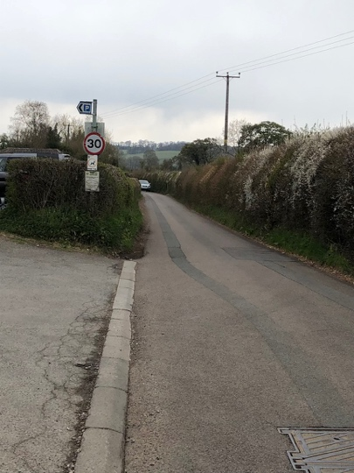 | 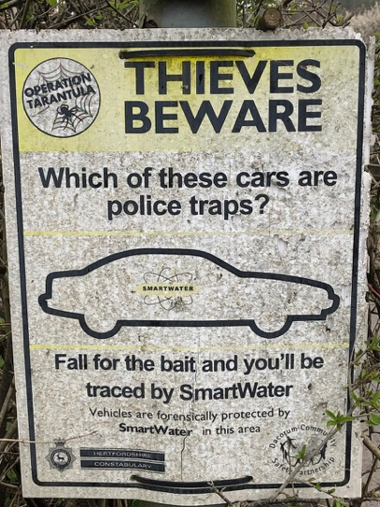 | AWAITING NEW PICTURE | AWAITING NEW PICTURE
Entrance to Recreation Ground | Police sign at Rectration Ground | Wooden logs separating Recreatiion Ground from parking area | Barrier between car park and rectreation ground.
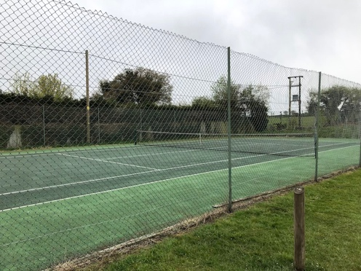 | AWAITING NEW PICTURE | AWAITING NEW PICTURE | 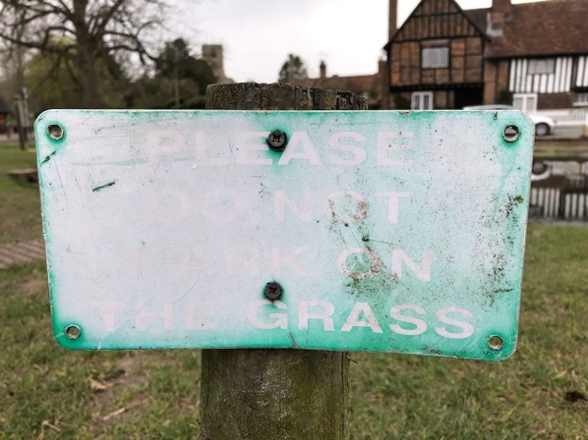
Tennis Court | Pond edge | Pond verge | Pond verge parking sign
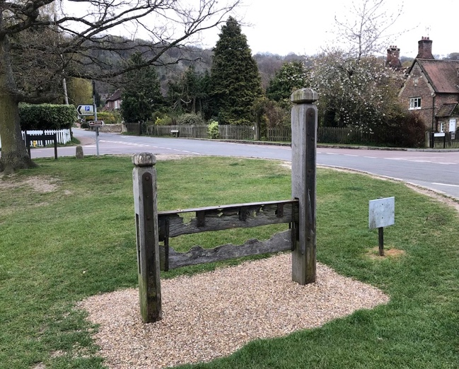 | AWAITING NEW PICTURE | 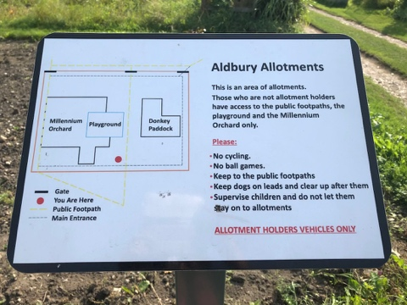 | AWAITING NEW PICTURE
Stocks and sign | Noticeboard | Allotment sign | Playground

